**Part 1:**

**Connecting to the DB server**

**Loading of the .js file:**



**Product table count:**

**Customer table count:**

**Transactions table count:**

**Transactions_contains table count:**



**Part 2:**

**1.**

**2.**

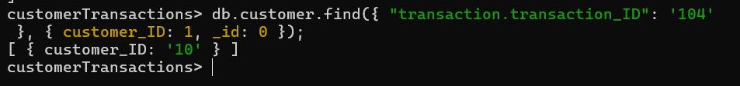

**3.**

**4.**

**5.**

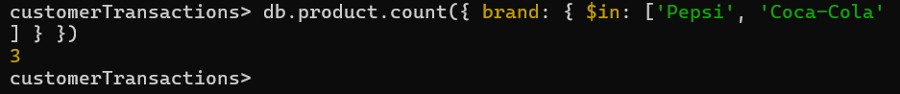

**6.**

**7.**

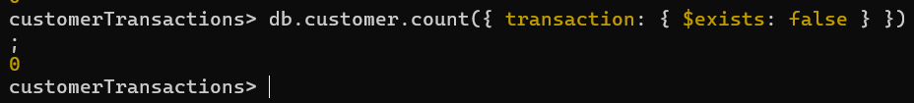

**8.**

